**PROJECT PROPOSAL**



**CSE-203L Circuit & Systems-II Lab**

**Fall 2022**

**SUBMITTED BY:**

Shahzad Bangash(21PWCSE1980)

Suleman Shah(21PWCSE1983)

Ali Asghar(21PWCSE2059)

**CLASS SECTION:**

C

**SUBMITTED TO:**

Engr. Faiz Ullah

**DATE:**

20th December, 2022

Department of Computer Systems Engineering

University of Engineering and Technology, Peshawar

**Project TITLE:**

**Automatic Water Management System**

**Problem statement:**

Whenever we are dealing with multiple channels, we want to have a flexible and strong channel controlling system. To be more specific, we have encountered a problem in which we have **multiple solenoid valves** and **one water resource**. Each **solenoid valve** is located at different house. So, we need to design a system in which there’ll be a controlled system for these **solenoid valves**. For instance, when one solenoid valve is **ON**, the others must be **OFF**. When all are **OFF**, any can be **ON**. In this way, **one water resource** would be shared among **different channels (solenoid valves)** but will be controlled by one solenoid valve at a time. The solenoid valves are **ON** for a specific time and then they are automatically **OFF**

**INTRODUCTION:**

We need to design a **system** in which we can select any input and then grant authority to that input only. For this purpose, we need a **microcontroller** which have the capability to make a decision and **grant authority** to the **selected input**. Our first proposed solution for a microcontroller is **ATmega328P** which is embedded in Arduino.

**Arduino** is an **open-source** **platform based** around **programmable** development **boards** that can be integrated into a range of **simple** and **complex** **projects**.

With the help of Arduino, we can program and design this system.

**TOOLS/EQUIPMENTS:**

* 1 x Arduino UNO
* 3 x Push Buttons
* 3 x 1/10k Ω Resistors
* 3 x 100 Ω Resistors
* 3 x DPDT Relays
* 3 x Diodes
* 3 x BC547 NPN Transistor
* Connecting Wires
* Veroboard
* Power Supply

**WORKING:**

The flow of this project is given below in the form of flowchart. There is **one water reservoir** and **multiple solenoid valves**. As soon as one of the switches is ON, the others are disconnected and will remain **closed** as long as one of the other is **ON**. So, Arduino will accept input signal from the currently active solenoid valves only. When all are in-active, Arduino could receive input from all three water pump holders. But as one of them is ON, then Arduino will shift priority to that particular house only.

**FLOWCHART:**

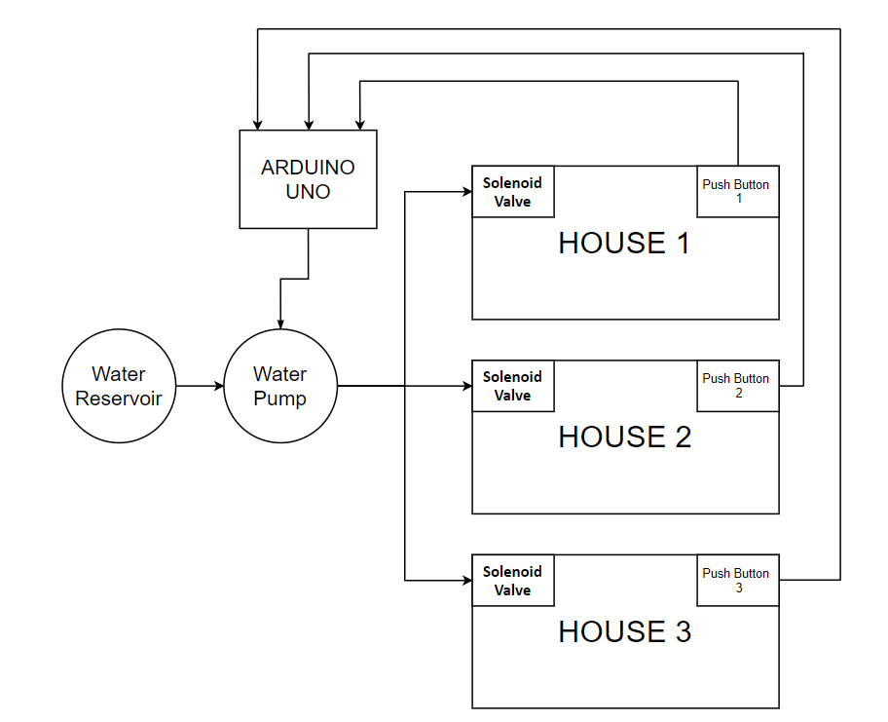

**CIRCUIT DIAGRAM IN PROTEUS:**

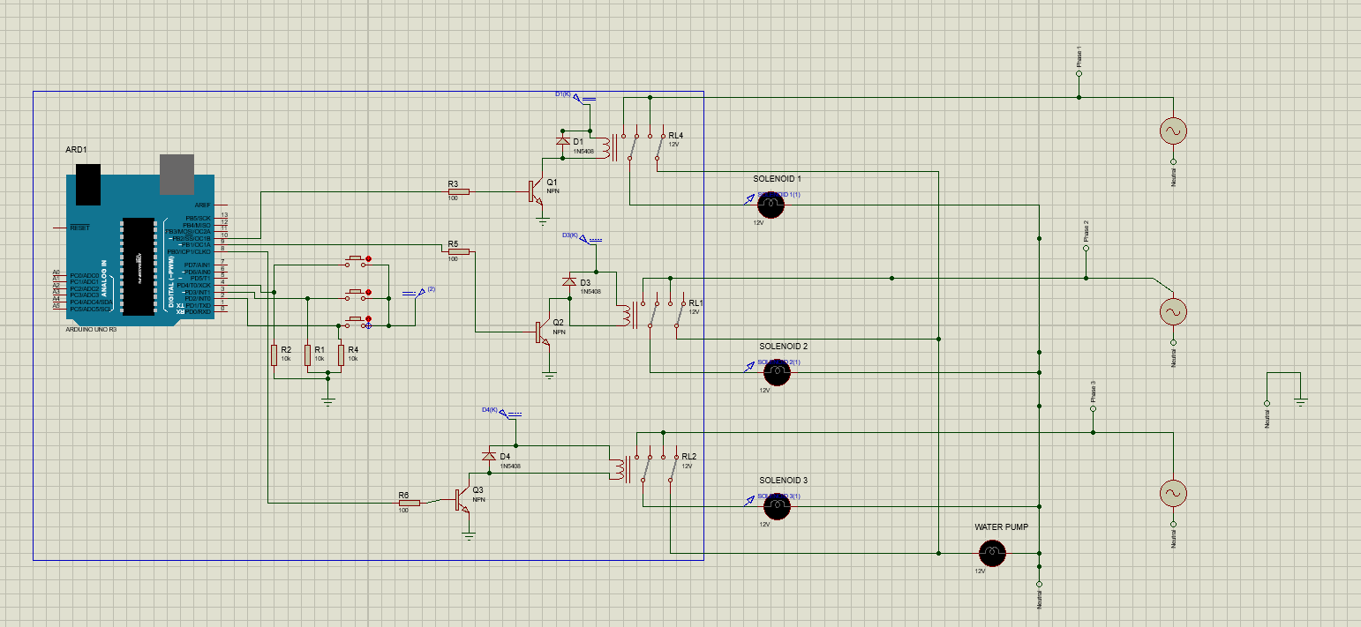

**ARDUINO CODE:**

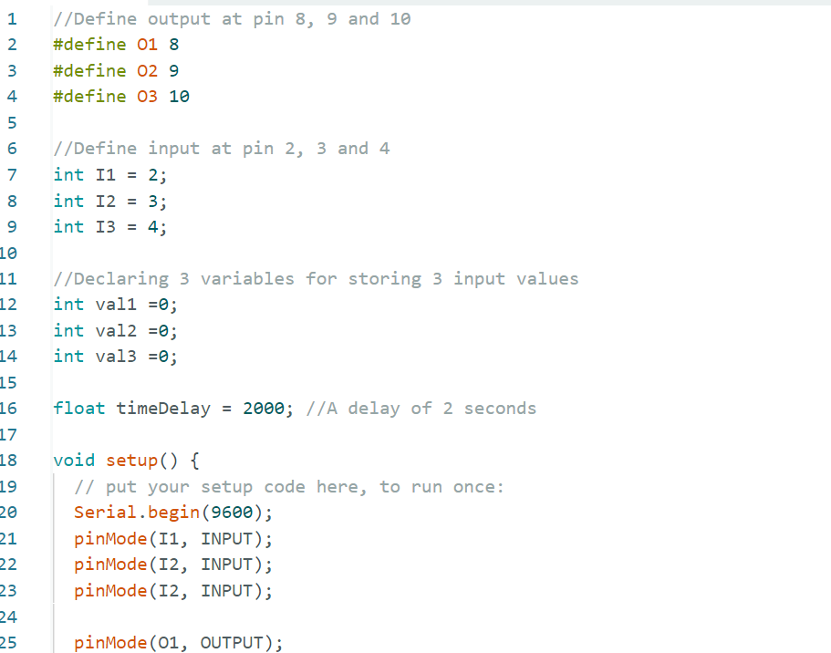

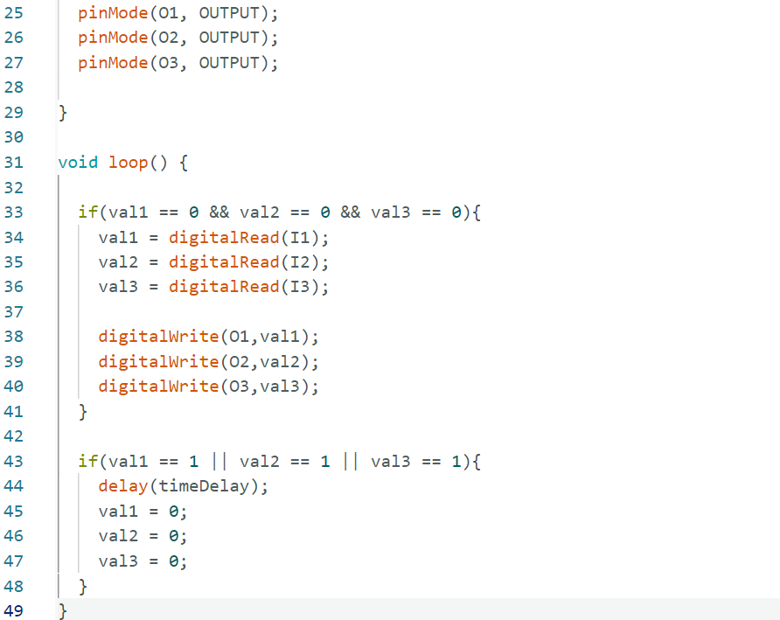

**RESULTS:**

With the help of this system, we can minimize the labor of manually switching off solenoid valves. Further, we can avoid the forbidden state (multiple channels open at a time).